
PUCIT
Punjab University College of Information Technology

Lahore Tour Guide
Sprint 2 Report

Table of Contents

SPRINT_2_rEPORT
1 INTRODCUTION 3
2 TEAM 3
3 SPRINT GOAL 3
4 SPRINT OVERVIEW 3
5 BURNDOWN CHART 4
6 SPRINT BACKLOG 4

Introduction
Nowadays, 87% travelers and tourists use navigation apps and smartphones while traveling to new places. Cities across the globe are looking for new ways to offer useful information to tourists and people unfamiliar with the city for a pleasant and guided stay. Many cities have come up with their own apps for the guidance of such people. We aim to develop and design a similar app that will not only give travelers and tourists easy access to the Lahore city’s points of interest. But also allow them to find and book the best place for their stay in the city.

Team
Supervisor: Ma’am Madiha Khalid

Members | Roll no
Maham Mubashir | BSEF17M008
Anzala Mohsan | BSEF17M018
Mubarra Naz | BSEF17M031
Bilal Mubarak (Scrum Master) | BSEF17M056

Sprint Goal
Designing remaining mockups of Lahore Tour Guide app reservation module using Figma as our design tool. We will create both front and back end for the designed screens. Database queries will also be implemented for respective screens.

Sprint Overview
Planned |  | Completed
Items | Hours | Items | Hours
12 | 200 | 12 | 200

Burndown Chart
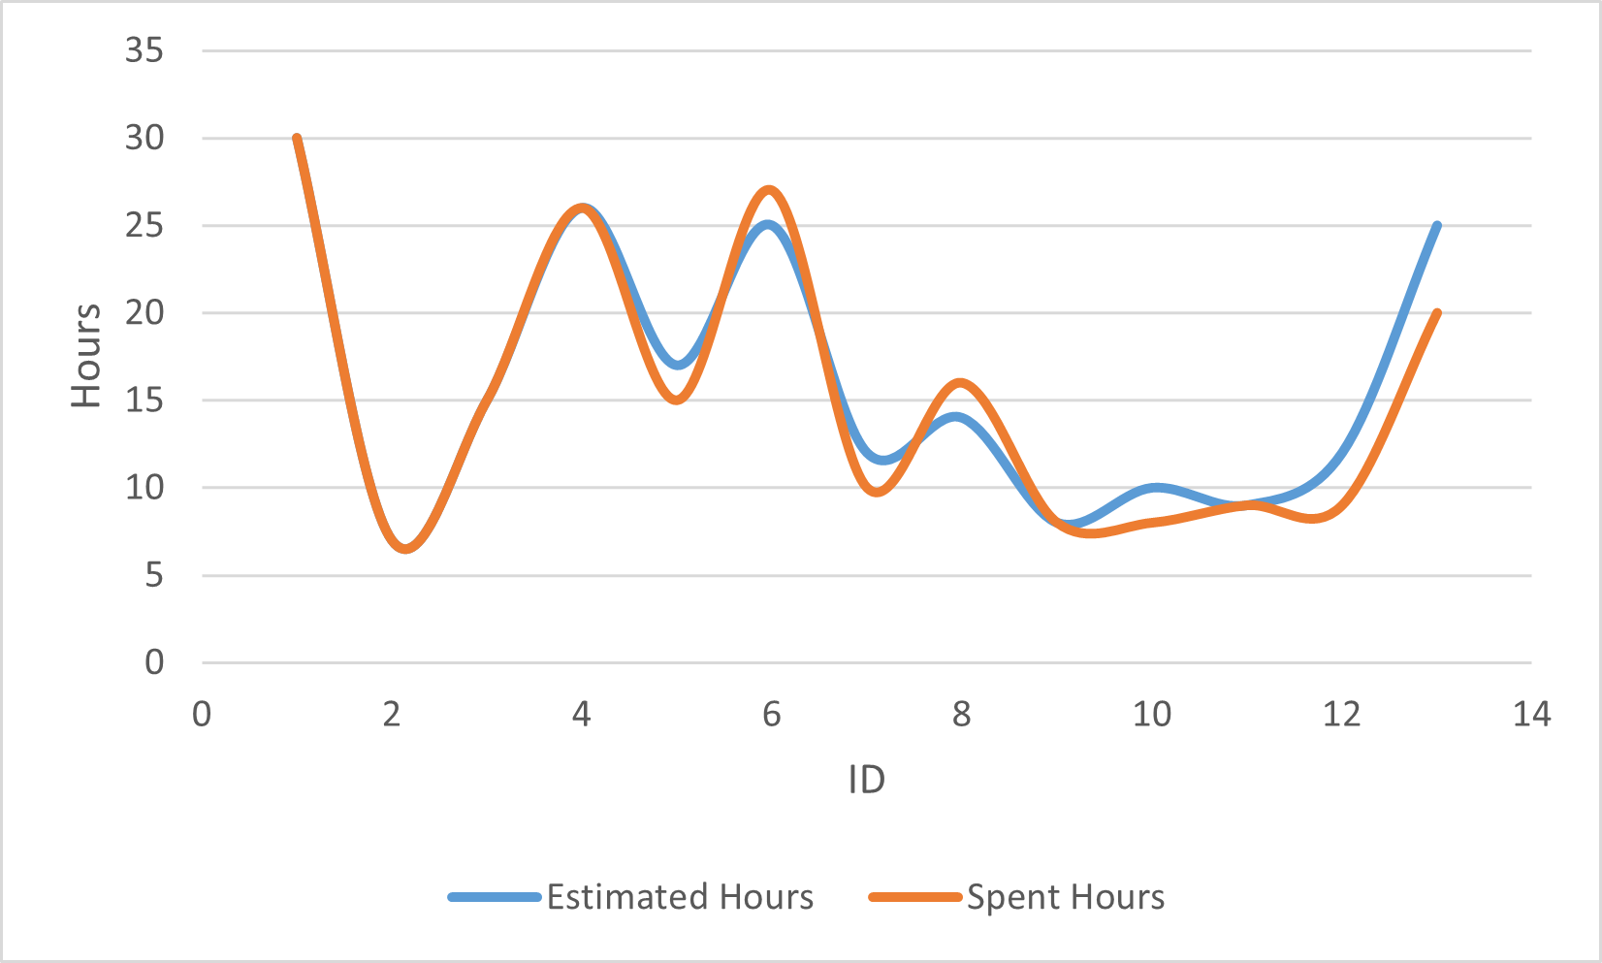

Sprint Backlog
ID | Title | Category | Assigned To | Status | Estimated Hours | Spent Hours
1 | Requirement gathering for sprint | Task | Maham Mubashir  Anzala Mohsan  Mubarra Naz  Bilal Mubarak | Done | 30 | 30
2 | Navigation module | Task | Anzala Mohsan | Done | 7 | 7
3 | Meeting related to UI design and task distributions | help | Maham Mubashir  Anzala Mohsan  Mubarra Naz  Bilal Mubarak | Done | 15 | 15
4 | UI design for the screens | Task | Maham Mubashir  Anzala Mohsan  Mubarra Naz  Bilal Mubarak | Done | 26 | 26
5 | Edit and delete Ad fucntionality | Task | Anzala Mohsan | Done | 17 | 15
6 | Chat fucntionality | Task | Bilal Mubarak  Anzala Mohsan | Done | 25 | 27
7 | Reservation requirement gathering functionality | Task | Maham Mubashir | Done | 12 | 10
8 | Credit card and payment fucntionality | Task | Mubarra Naz  Maham Mubashir | Done | 14 | 16
9 | Ads Screen | Task | Mubarra Naz | Done | 8 | 8
10 | Reviews Tab fucntionality | Task | Mubarra Naz | Done | 10 | 8
11 | Ads Description fucntionality | Task | Maham Mubashir | Done | 9 | 9
12 | Direction to room functionality | Task | Bilal Mubarak | Done | 12 | 9
13 | Meeting related to issues, collaborations and feedbacks | Help | Maham Mubashir  Anzala Mohsan  Mubarra Naz  Bilal Mubarak | Done | 25 | 20

